ee354L_GCD_N4_A7.zip 9/25/2023
This zip file contains two subfolders, one for the N4 board and the other for the A7 board.
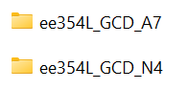
Each folder has 6 files. Three of the six files are common to both. We kept identical copies of these common files in both directories. The three others are different abd they bear _N4 or _A7 suffixes in their names.
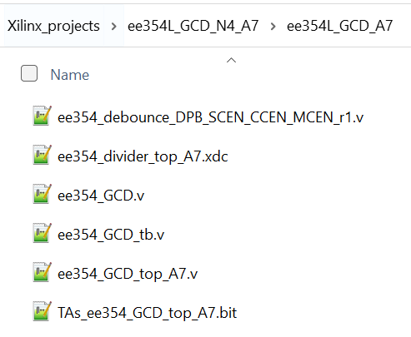
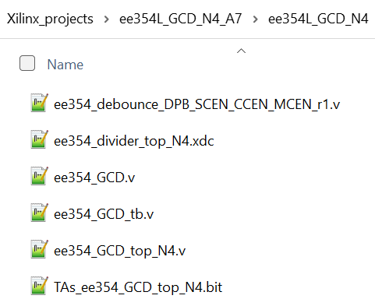
The EE354L Teaching team

